Pre – Order Form
St. Joseph’s Youth Group Fundraiser
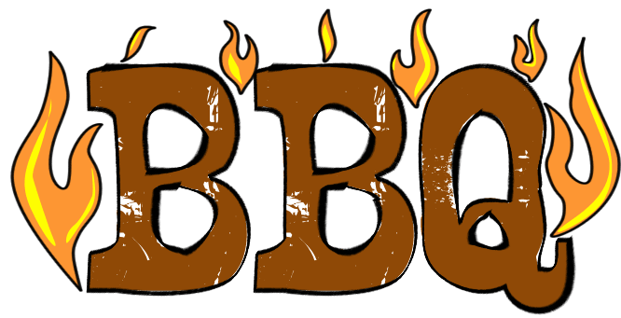
Saturday, September 22 – 11:00 AM – 7:00 PM
Sunday, September 23 – 9:00 AM - NOON

Romans 14:2 BBQ (our very own parishioners) is back! The youth group will be serving meals and sandwiches again this year! You can pre-order this fabulous food to enjoy with your family or freeze for later!
All proceeds will support the Youth Group Retreats and Pro-Life Trip!
Name: _______________________________ Phone Number ______________________________
Email address (required) __________________________________________________________
I would like to order:
___ 5 Lb tray of Pulled Pork $35
___ 5 Lb tray of Pulled Chicken $35
___ Lbs of Sliced Brisket (14 dollars per pound with 5 LB Minimum)
___ Slab of Baby Back Ribs $20
Pick-up Time: (All preorders will be picked up Saturday, September 23)

____ 11:00 AM – 2:00 PM OR _____ 2:00 PM – 5:00 PM

I would like my order to be ______(refrigerated) or _____(warm) when I pick it up.

Order form can be dropped off or mailed to the Parish office no later than Sunday, September 18th. Please make checks payable to St. Joseph Parish.
An email confirmation with pick up information will be sent.

