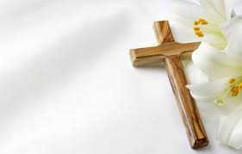

MASS OF REMEMBRANCE

You are invited to participate in the Mass and Candle Lighting Ceremony
On the Evening of
Friday, November 2, 2018 at 7:00 p.m.
to honor loved ones who have died.

- You may request a candle for each individual person you want to be remembered.
- You may request just one candle for all deceased members in a family by using the surname of the family.
- You may choose to have a person or family remembered without the purchase of a candle.

Refreshments will be served after the Mass in the St. Joseph Room.

If you purchase candles, you may take them home with you after the Mass as a remembrance.

Please fill in the form below and place it in an envelope with a $3.00 donation for each candle you wish
to light.
Return the envelope marked “Mass of Remembrance” to the Parish Center or put it in the weekend collection basket no later than Wednesday, October 24th.

Contact Maria Kilmer (636-541-0231) with any questions.

Example shown below:

NAME # Candles
John Smith 1
The Johnson Family 1
The Cranston Family 0
-----------------------------------------------------------------------------------------------------------------------------------------------
PLEASE PRINT

NAME #CANDLES NAME #CANDLES

____________________________________ _________ _________________________________________ ________

____________________________________ _________ ________________________________________ ________

____________________________________ _________ _________________________________________ ________

____________________________________ _________ _________________________________________ _________

TOTAL NUMBER OF CANDLES ORDERED _________ AMOUNT ENCLOSED ____________________

Requested by: ____________________________________________ Phone Number: ____________________________

