SENIOR SAINTS
Upcoming Events 2022 – 2023

THURSDAY 9/22/22 (DAY event)
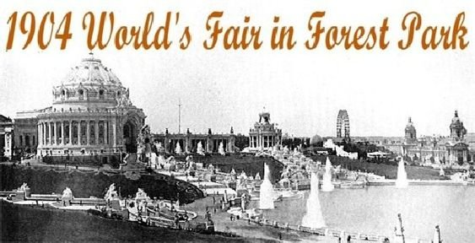
Celebrating the 1904 World’s Fair

Wednesday, 10/19/22 (Evening event)
🎃 Halloween Costume Party

Thursday 11/17/22 (day event)
🧥Food and Coat Drive for St. Patrick’s Center

Wednesday, 12/15/22 (Evening Event)
🌲Donna Cori Gibson performance
Christmas Dinner

Thursday, 1/12/23 (Day Event)
Card Party 🃘
Teach and Learn new card/table games

Wednesday, 2/8/23 (Evening Event)
Larry Johnson playing with the Band, “Finale!”
Special Valentine Dinner❤️

Thursday, 3/9/23 (Day Event)
Touring St. Joseph Shrine, O’Fallon, MO
Mass in the Chapel ✞

🛳 Thursday, 5/11/23 (Day Event)
Miss Augusta Boat Ride.

⚾️THURSDAY 6/8/23 (DAY EVENT)
Bus Trip, St. Louis Cardinals Baseball Game

